GOVERNMENT OF MIZORAM
POWER AND ELECTRICITY DEPARTMENT
MIZORAM : AIZAWL

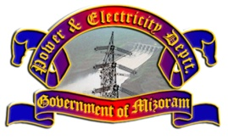

TENDER DOCUMENT

NOTICE INVITING TENDER NO 1 OF 2018-2019
(Vide No. 1025/1/18-E-in-C(PD)/4)

Name of work : Design, Manufacture, Supply, testing and commissioning of 1no of 6.3MVA, 132/33kV Power Transformer at Bairabi 132kV Sub-Station

July, 2018

Office of the Engineer-in-Chief, P&E Deptt : Aizawl, Mizoram

